EX:4b | EXPLORATORY DATA ANALYSIS (EDA) – DATA INSPECTION, FILTERING, STATISTICAL ANALYSIS AND CORRELATION  (USING IMPORTED BREAST CANCER DATA)
DATE:

AIM:

To perform data inspection, filtering, grouping, aggregation, descriptive statistical analysis, and correlation analysis by importing breast cancer data using Pandas and visualize the results using Matplotlib .

ALGORITHM:

- Start.
- Import the required libraries, Pandas and Matplotlib.
- Read the Breast Cancer dataset from the CSV file into a DataFrame.
- Display the dataset, its data types, dimensions, and first few records.
- Filter the required records based on diagnosis and radius_mean.
- Sort the dataset based on area_mean in descending order.
- Calculate Mean, Median, Mode, Standard Deviation, and statistical summary.
- Perform grouping and aggregation based on diagnosis.
- Calculate the correlation between radius_mean and area_mean.
- Visualize the results using Bar Chart, Box Plot, and Scatter Plot.
- Display and interpret the outputs.
- Stop.

PROGRAM:

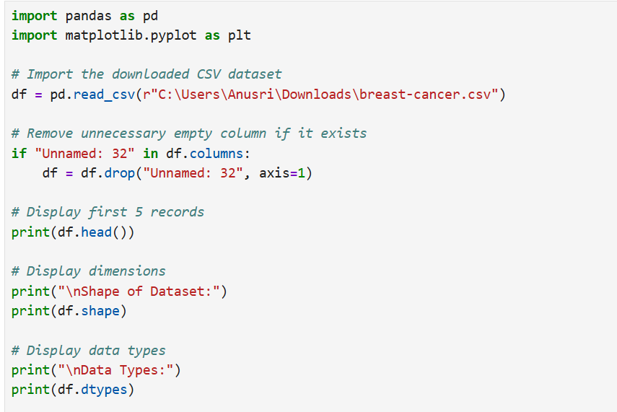

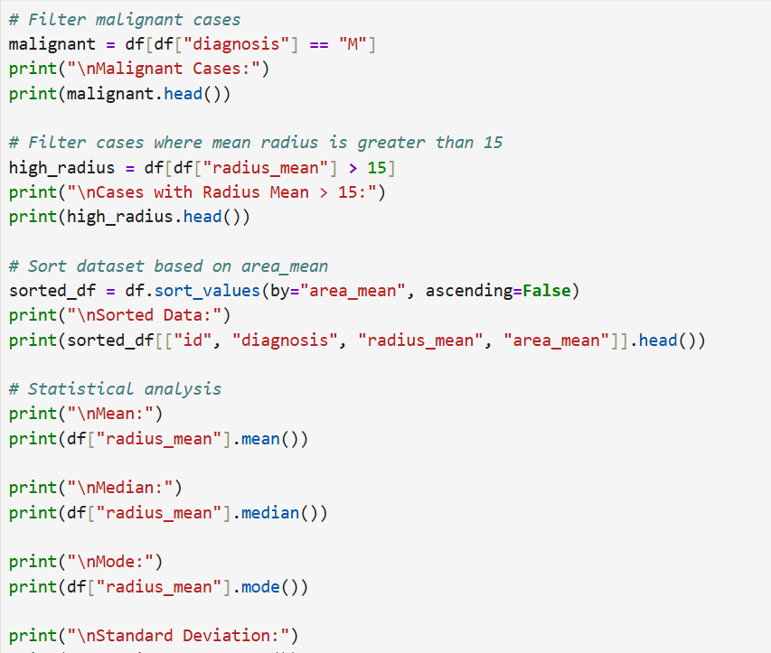
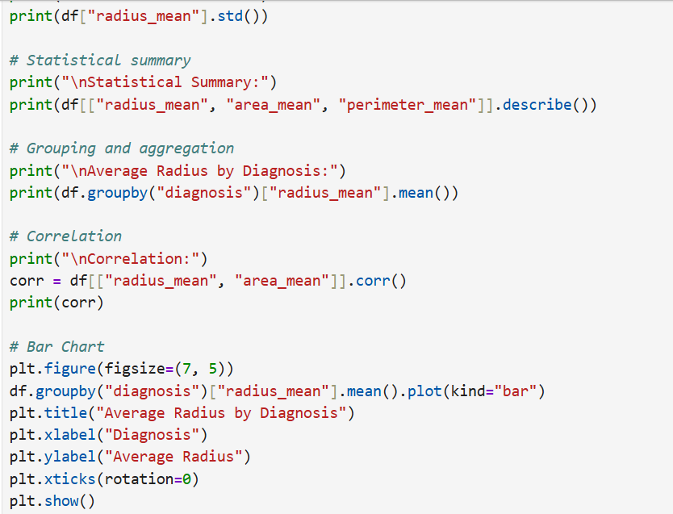
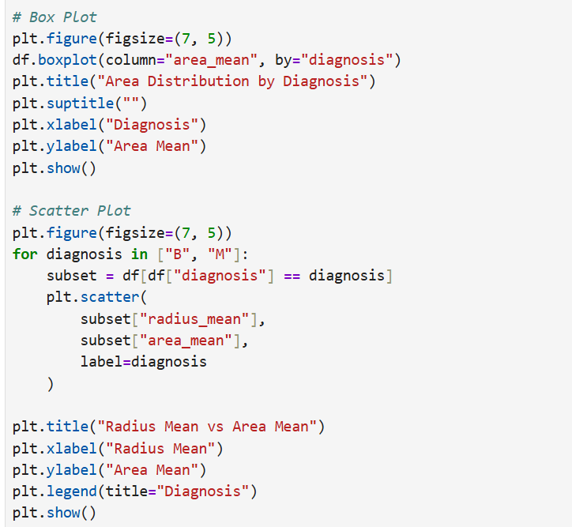

OUTPUT:

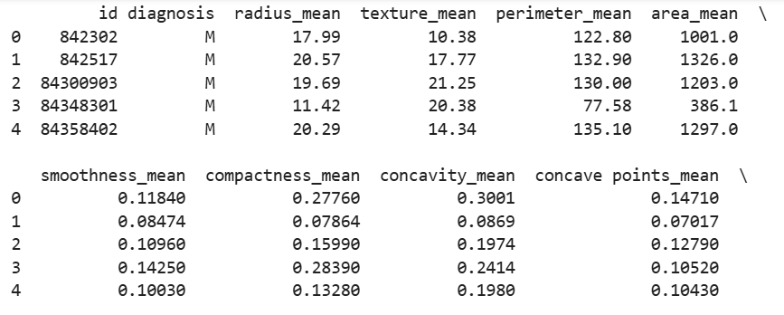

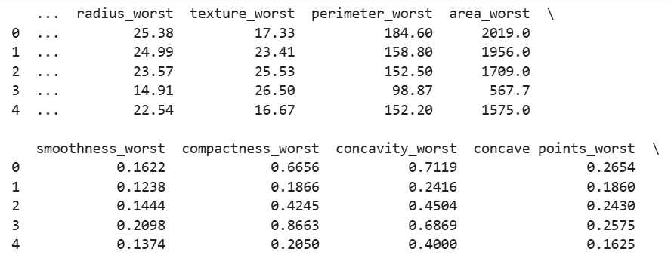

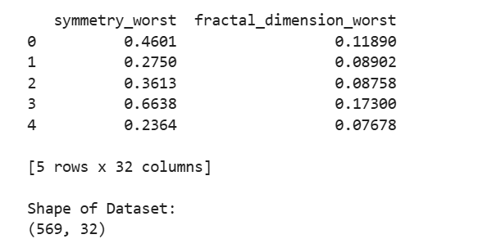

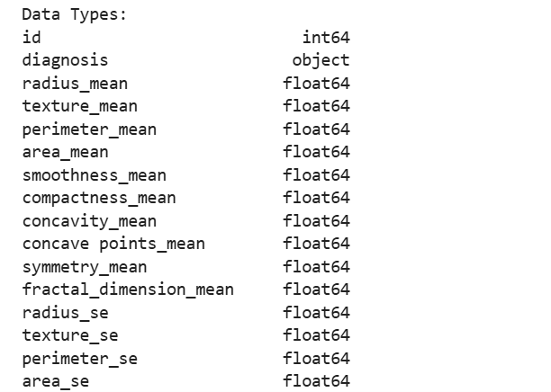

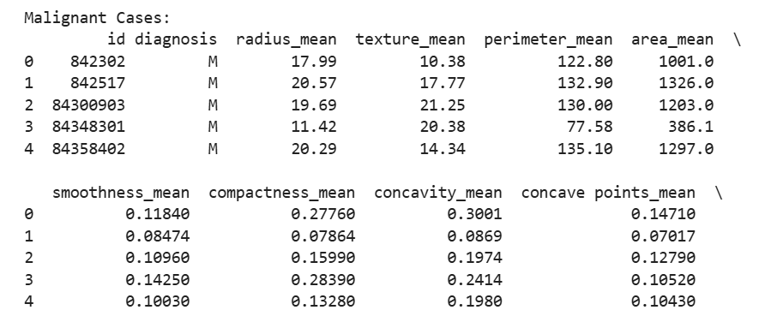

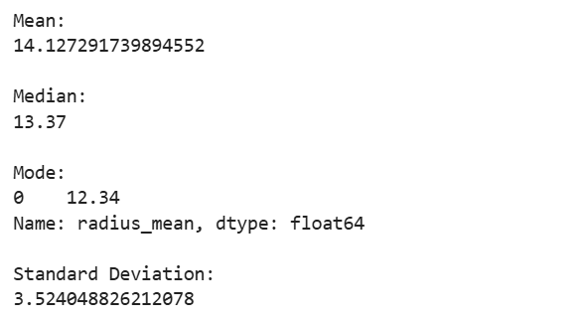

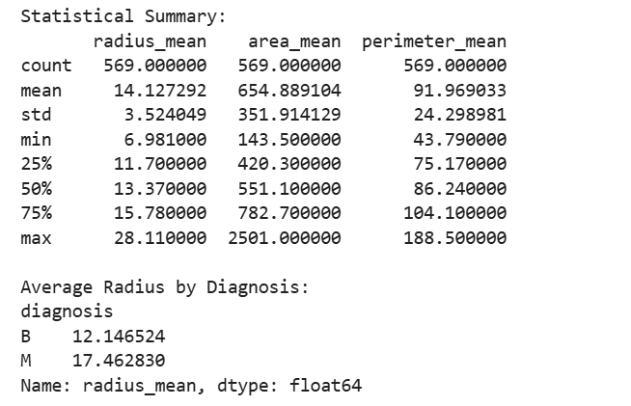

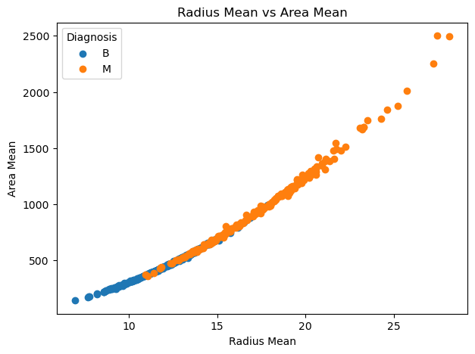

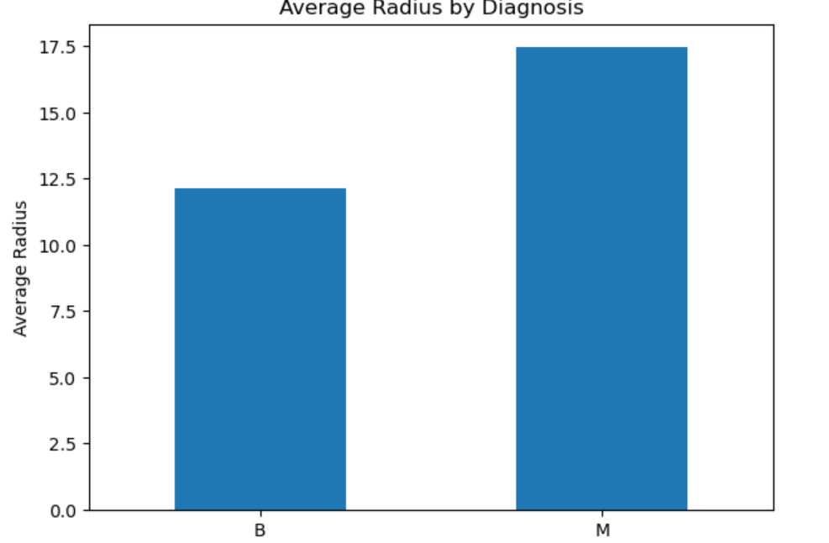

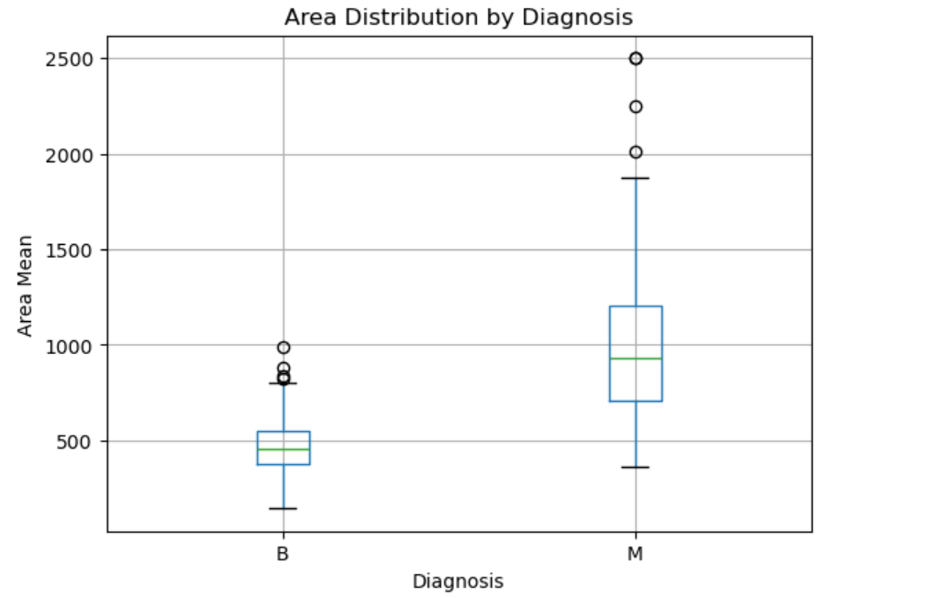

RESULT:

Thus, data inspection, filtering, sorting, descriptive statistical analysis, grouping, aggregation, and correlation analysis were successfully performed using Pandas. The analytical results were visualized and interpreted successfully.

